At Seawinds we like to know if you are happy with the supported employment service.





Please circle your answer e.g.  **Yes**  **No**

Please add your comments in the spaces provided to help us address any issues.

Name of participant:

Date:





|  |  |  |  |
| --- | --- | --- | --- |
| 1. | *Was this form filled in on the participant’s behalf by a parent/carer?* | Yes | No |

**Rights**





|  |  |  |  |
| --- | --- | --- | --- |
| 3. | *If you have a problem at Seawinds do you speak up?* | Yes | No |





|  |  |  |  |
| --- | --- | --- | --- |
| 4. | *If someone hurt you would you tell someone at Seawinds/Kyeema?* | Yes | No |

# **Supported Employees**





|  |  |  |  |
| --- | --- | --- | --- |
| 5. | *Do you like your job at Seawinds?* | Yes | No |





|  |  |  |  |
| --- | --- | --- | --- |
| 6. | *Do you feel that there is enough variety in the work that you do?* | Yes | No |





|  |  |  |  |
| --- | --- | --- | --- |
| 7. | *Would you like to learn new skills?* | Yes | No |

If yes, what skills would you like to learn?

|  |  |  |  |
| --- | --- | --- | --- |
| 8. | *Do Seawinds staff give you enough help when you need it?* | **Yes**  Description: Thumbs Down Button Stock Photography  Description: Thumbs up Royalty Free Stock Images | **No** |

|  |  |  |
| --- | --- | --- |
| *Would you feel comfortable bringing up any issues/ideas with Managers or the CEO?* | Description: Thumbs Down Button Stock Photography  Description: Thumbs up Royalty Free Stock Images  **Yes** | **No** |
| *What (if anything) do you like about Seawinds?* | _____________________________________  _____________________________________ | |

|  |  |  |
| --- | --- | --- |
| *Do you need to speak to an independent advocate about any concerns you have right now?* | Description: Thumbs Down Button Stock Photography  Description: Thumbs up Royalty Free Stock Images  ***Yes*** | ***No*** |

If yes, please write your name and contact phone number:

Name:

Phone:

**Community Advocates:**

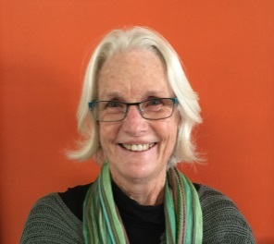****

*Iain McDonald Sue Miller*